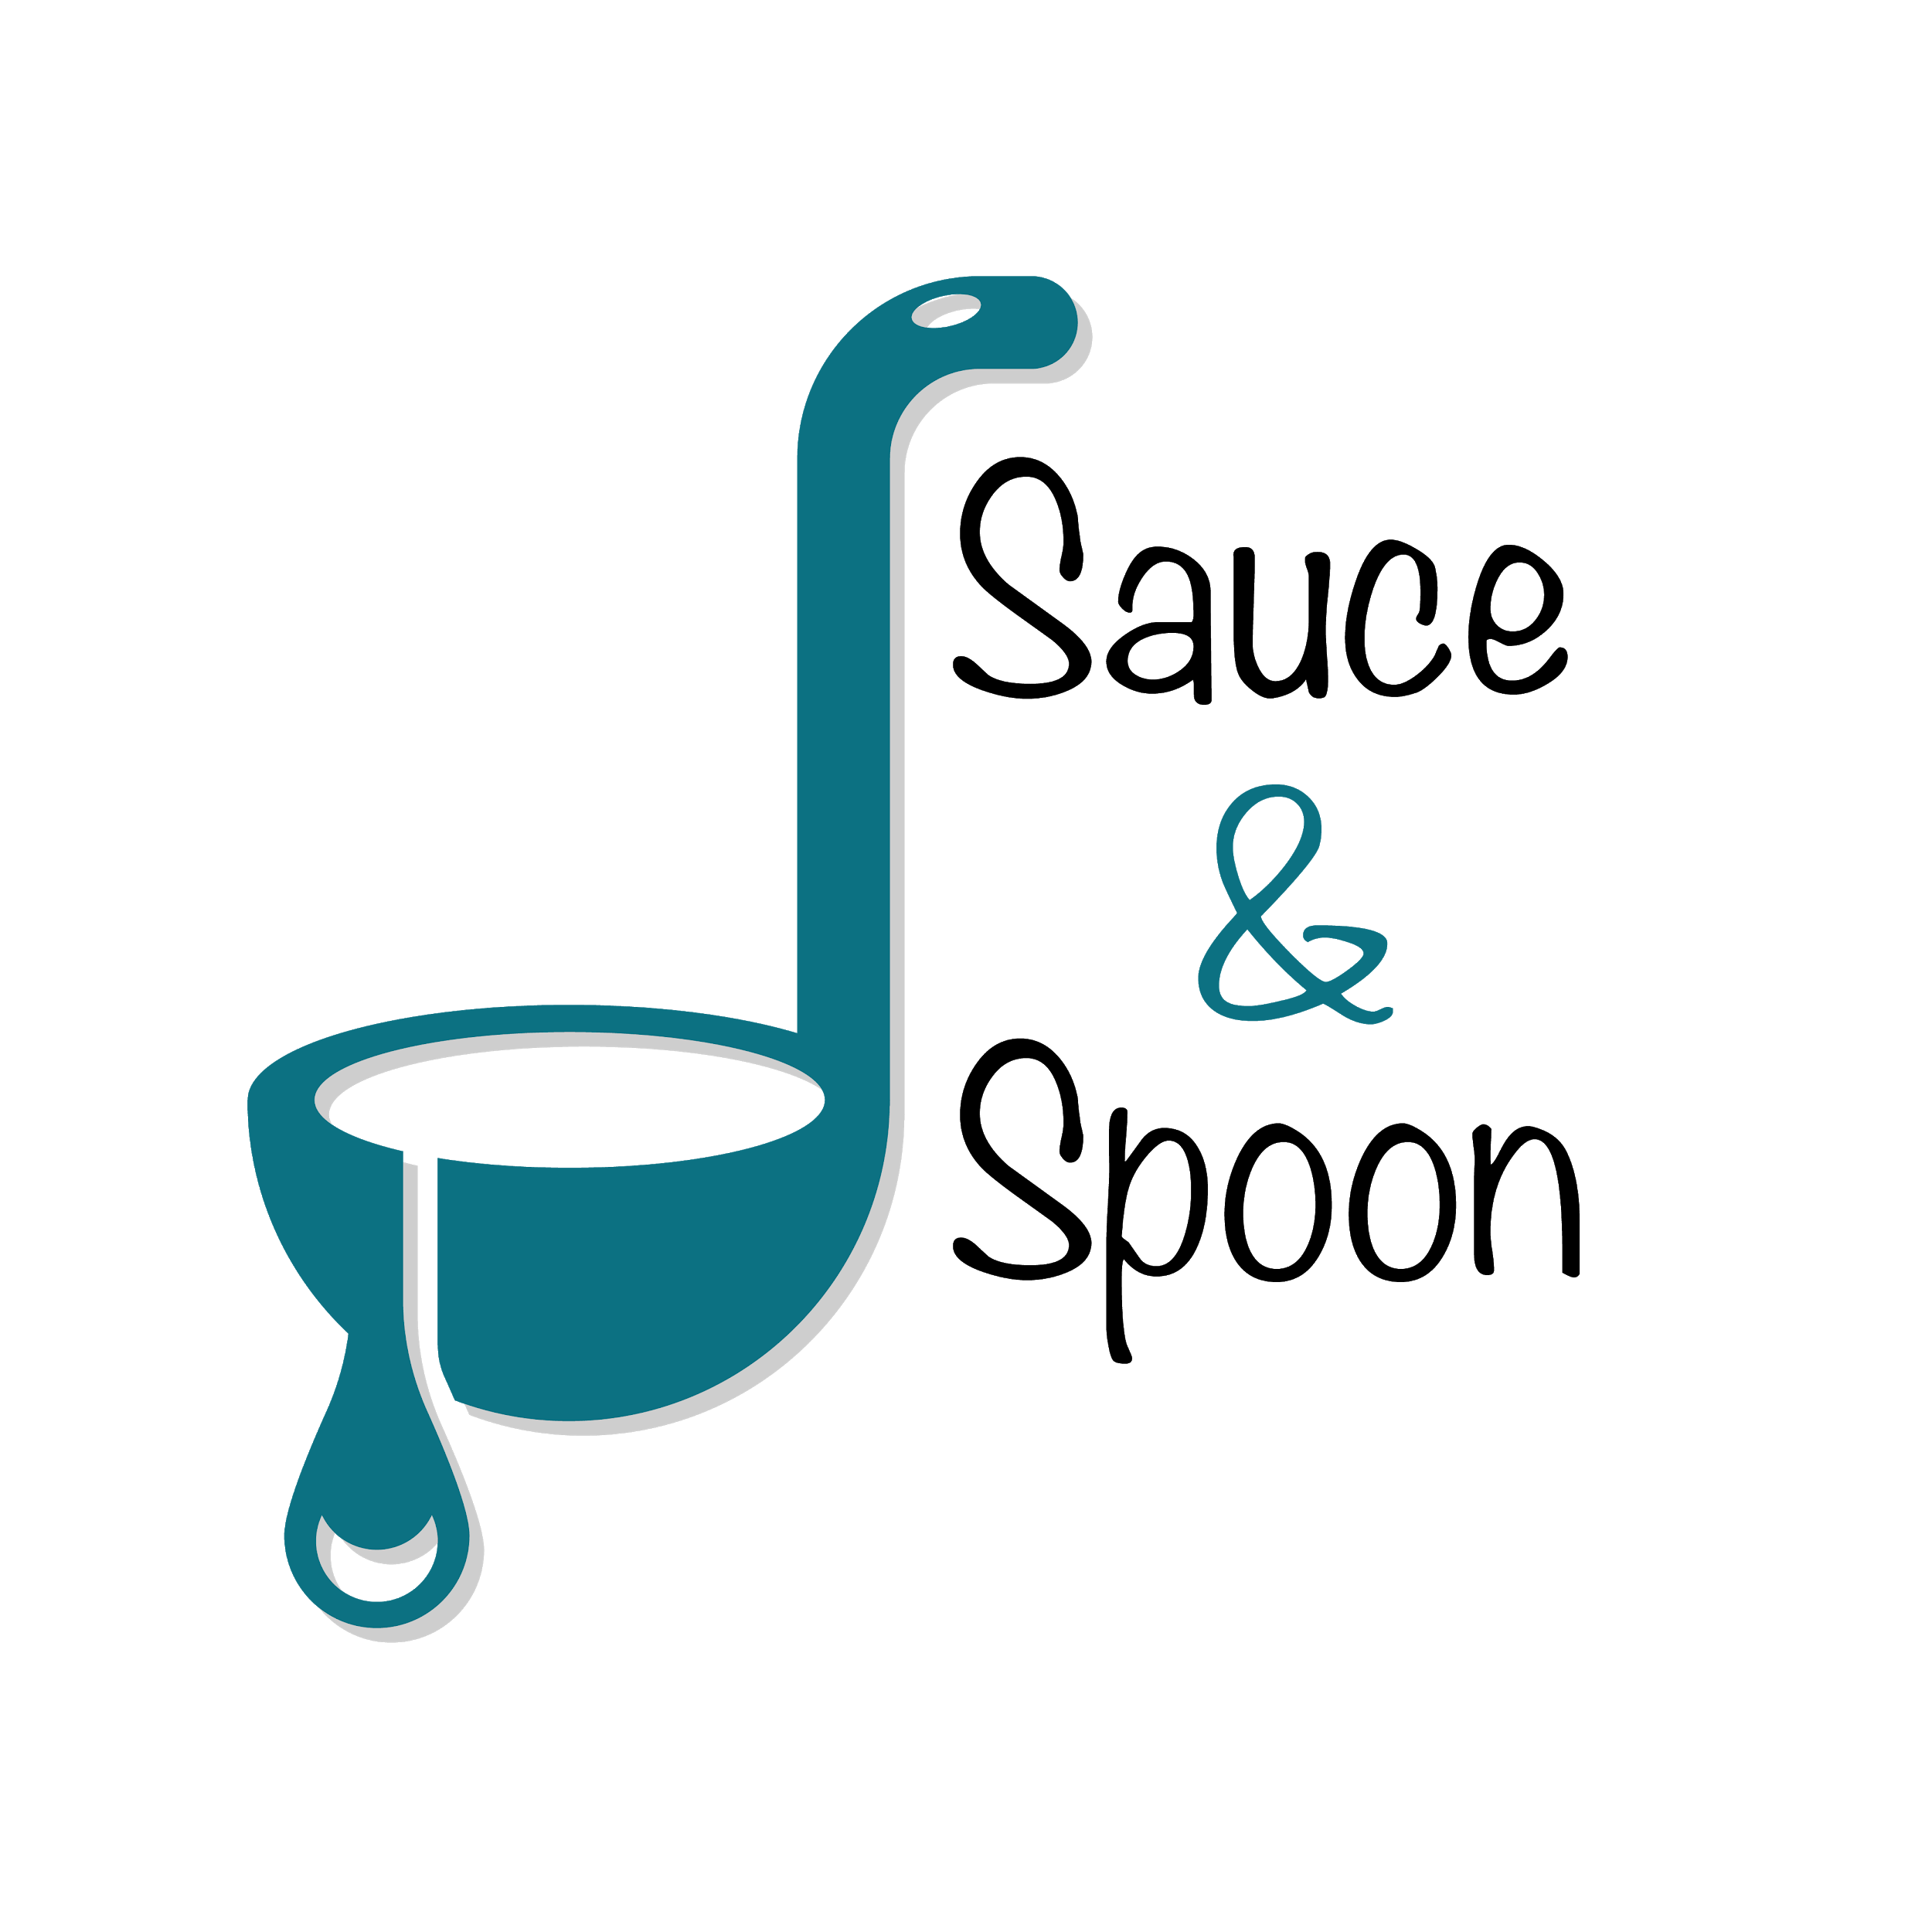

Project Charter: Sauce & Spoon Tablets Project

DATE: 13/07/23

|  |
| --- |
| **Project Summary** |
| To launch a pilot rollout of tabletop menu tablets at two of our restaurant locations, Sauce & Spoon North and Sauce & Spoon Downtown. That way, guests can place their orders on the tablets as soon as they arrive at the restaurant, rather than waiting for a server to attend to them. |

|  |
| --- |
| **Project Goals** |
| * To rollout the pilot in the bar * Increase the product mix * Increase average daily guest by 10% by the end of June by adding appetizer sales by 15% * Decrease the average table turn time to about 30min by the end of May by using the tablets to increase the speed of orders by 10% * Cut food waste by 25% by the end of June by using the tablets to get more accurate orders. * Increase appetizer sale * Timing of pilot to be set for April * To ensure guest have a good experience |

|  |
| --- |
| **Deliverables** |
| * A plan to train the staff on the new system. * Clear data point to track metric * Tablets to be installed in the bar of 2 restaurant location * To use appetizer sales to increase sales * Improve the smooth running of the kitchen * Metric of kitchen staff |

|  |
| --- |
| **Scope and Exclusion** |
| **In-Scope:**   * Employee satisfaction   **Out-of-Scope:**   * Policy Changes |

|  |
| --- |
| **Benefits & Costs** |
| **Benefits:**   * Improve smoother running of the kitchen * Guest have good dining experience * Increase sales * Reduce customer waiting time   **Costs:**   * $50,550 |

|  |
| --- |
| **Appendix:** |
| * Reallocate payroll to hire more kitchen staff. This was not resolved * Decreasing guest wait time: Removed as goal * Timing of Pilot: moved to from April to the end of June * Policy changes: moved to an operations discussion |